Crowd funding data analysis:

Since 2010, around 1000 projects of various categories were launched through Crowd funding platform, out of which 56.5% of them has been successful to receive funds while 36.4% has failed.

Three conclusions:

1. Based on category, Technology, publishing and photography sectors has shown success ratio between 60-70% . If we talk about the sub categories in Technology sector web and wearable projects received funding through total 64 successful projects. Where as in Theatre category , there were total 344 projects out of which 187 were successful, 132 were failed, 23 got cancelled and 2 projects are still live.

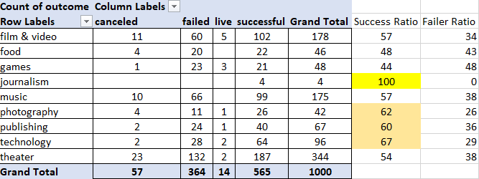

1. If we compare the projects by its funding goal, lower budget projects with goal of USD 1000 to 4999, the project success ratio is higher which is 83% with 16 percentage of failure. When goal gets USD 50,000 and above the percentage of success decreases.
2. There are 14 projects which are live ,out of which 5 falls under film and video category and others are scattered between technology, theatre, games, photography and publishing.

**Limitation about dataset.**

Its missing the data after 2019.

Not clear about the purpose of the columns Staff pick and Spotlight.